OS Lab -4 -Scheduling

Praneesh R V

CB.SC.U4CYS23036

Code Referred from ChatGPT and Geeks4Geeks

Qn 1,

FCFS

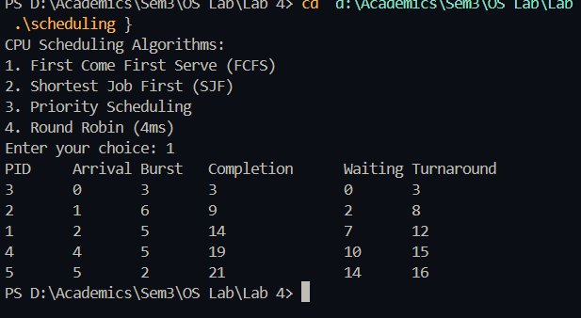

Qn 2,

SJF

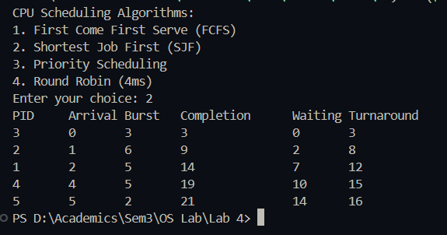

Qn 3,

Priority Scheduling

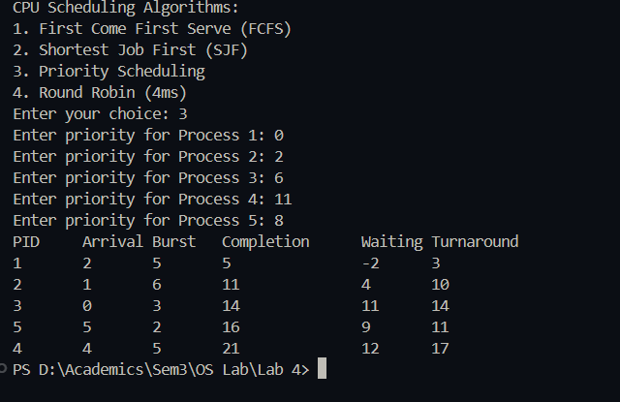

Qn 4,

Round Robin

